Section n: Requirements diagram

### n.1 Use case Diagrams

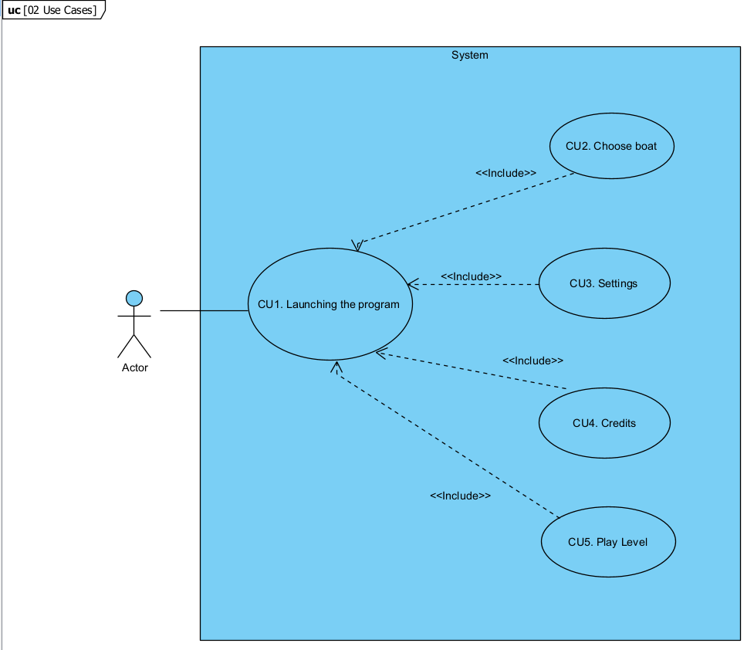

### n.1 Textual Description of the use cases

**Unique identifier:** CU1. Launching the program

**Context of use**

⦁ The user clicks on the executable to launch the game. Once this is done a menu is displayed in which the player can select between “play level”, “choose boat”, “settings” and “credits”.

**Preconditions and activation**

⦁ The user´s computer is powerful enough to run the game.

⦁ The program is properly coded, and the process launches once we run the executable.

**Guarantees of success or post-conditions**

⦁ The program properly displays the main menu.

**Main scenario**

⦁ The user has installed the game.

⦁ The user launches the program properly.

⦁ The menu is loaded and displayed on the user screen.

⦁ The user can navigate through the main menu.

**Alternative scenarios**

⦁ The user´s computer does not have the necessary resources to run the game appropriately.

⦁ There has been a problem with the installation and the executable behaves oddly.

**Unique identifier:** CU2. Choose boat.

**Context of use**

⦁ When the user clicks on the “choose boat” button, he will be able to see all the boats and their trade-offs, and he will be able to navigate through them to choose the one he prefers the most.

**Preconditions and activation**

⦁ The user is already running the game and in the main menu.

⦁ The user´s game is running smoothly.

**Guarantees of success or post-conditions**

⦁ The boat selection menu is properly displayed.

⦁ The user can navigate through the menu and see the boats.

**Main scenario**

⦁ The user is on the main menu.

⦁ He clicks on the “choose boat” button.

⦁ The user can see all the boats.

⦁ The user selects a boat, and that boat is loaded for the next run.

⦁ The user goes back to the main menu.

**Alternative scenarios**

⦁ The user doesn´t select a boat and the first boat available in the selection is automatically selected for them.

**Unique identifier:** CU3. Settings

**Context of use**

⦁ When the user clicks on the “settings” option, a menu in which he can configure various aspects of the game is displayed.

**Preconditions and activation**

⦁ The user is already running the game and in the main menu.

⦁ The button is properly implemented.

**Guarantees of success or post-conditions**

⦁ The user can configure the setting the way he wants according to the options he is given.

**Main scenario**

⦁ The user is on the main menu.

⦁ The user wants to change some aspect of the game´s settings.

⦁ The user clicks on the “setting” button and some options are displayed.

⦁ The user modifies some aspects of the game and saves the changes. The game´s behavior is modified accordingly.

⦁ The user goes back to the main menu with the changes applied.

**Alternative scenarios**

⦁ The user does not change any settings and the game keeps behaving in the same way.

⦁ The user makes some changes but does not save them. Not altering the way, the game behaves.

**Unique identifier:**CU4. Credits

**Context of use**

⦁ The user is on the main menu, and he wants to see the credits of the game.

**Preconditions and activation**

⦁ The user is already running the game and in the main menu.

⦁ The button is properly implemented.

**Guarantees of success or post-conditions**

⦁ The user can see all the people that participated in creating the game once he clicks on the “credits” button.

**Main scenario**

⦁ The user is on the main menu.

⦁ The user wants to see who created the game.

⦁ The user clicks on the “credits” button.

⦁ A video is displayed in which the player can see all the people that were involved on the game development.

⦁ Once the video ends, the player returns to the main menu.

**Alternative scenarios**

⦁ The player decides to finish the video abruptly without seeing it all and he is returned to the main menu without issues.

**Unique identifier:**CU5. Play Level

**Context of use**

⦁ The user wants to play the game, so once he is on the main menu he clicks on the “play level” button, initializing the run with the settings and boat he had previously selected.

**Preconditions and activation**

⦁ The user´s computer is powerful enough to run the game.

⦁ The user is already running the game and in the main menu.

⦁ The button is properly implemented.

**Guarantees of success or post-conditions**

⦁ The run will launch.

⦁ The boats, obstacles and scenery will be loaded on screen.

⦁ The user will be able to complete the run and control the boat throughout it.

**Main scenario**

⦁ The user has a powerful enough computer.

⦁ The user is already on the main menu and decides to click on the “play level” button.

⦁ Once the button is pressed the user will enter the run with the boat and settings he had selected.

⦁ Inside the run the player can control the boat and avoid obstacles.

⦁ If the player crashes with enough obstacles he will lose all his hp and the first time, an after-life Simon says like mini-game will be launched.

⦁ If the player completes the mini game successfully his hp will be restored and he will come back to the point in which he died.

⦁ Once the run is complete, he will advance to the next level or if found in the last one he will win the game.

⦁ After finishing the run, either winning or losing, progress will be saved, and he will return to the main menu.

**Alternative scenarios**

⦁ The user decides to exit mid-game, not saving any progress and returning to the main menu.